# UCSD Men’s Soccer 2023 Season Analysis

## League Success

* **Deep Completed Passes** - For every additional deep completed pass per game on average the points a team finishes with increases by 1.64.
* **Throw In Percentage** - 10% increase in throw in percentage the expected points a team gets increase by 4.6.
* **Recoveries** - For every 5 recoveries per game there is an expected increase of 2 points.
* **Shots** - For every additional shot per game the points a team is expected to increase 1.96 points.

## UCSD Success

* **Shots**:
  + For every 5 shots a player takes they are expected to score 1
  + Increasing shot on target % leads to better performance
  + Higher percentage when shooting towards the left side of the goal.
* **Forward Passing Accuracy**:
  + For every 4% increase in forward pass accuracy the goal differential is expected to increase by 1. Increasing forward pass accuracy decreases goals conceded.
  + Wellerstein is crucial to build up and attack and has lowest forward passing accuracy
* **Taking Players On:**
  + 1st in league in offensive duels accuracy
  + Have the most success taking players on just to the side of zone 14.
  + McGee and Carvalho very successful in taking players on with success over 60%
* **Crosses:**
  + For every 5 deep completed crosses we are expected to score 1 goal
  + Crossing accuracy was average in the league
  + Valverde was best crosser with a crossing accuracy of 56%
* **Physicality:**
  + For every yellow gained goal differential on average increase by 1
  + Yellow cards say how intensely and physical we are playing highly correlates to less conceded goals.
* **Defense:**
  + One of UCSD’s worst areas with 1.44 conceded goals per game
  + Allow substantially more passes per defensive action than other teams
  + Lowest defensive duels accuracy in the league
  + Wellerstein has the highest duel win rate while Redington has the worst on team
  + Goalkeeping - UCSD had way more goals conceded than expected at a value of 5.96 significantly greater than any other keeper in the league.

## Parameters to Hit

* Goal differential average per game of .4
  + Currently at -.6 goal differential per game
* 1.4 goals scored per game
  + Currently at 1.33 goals per game
  + If you score 1 goal you win 33% of the time. If you score 2 or more goals in a game you win 83.8% of the time. If you score 0 goals you lose 70% of the time
* 1 conceded goals per game.
  + Currently at 1.93 conceded goals per game.

Using these metrics you are expected to win 48% of the games and attain an average of 15.5 points in the season putting UCSD in the top 3 teams in the league.

### Features to hit goal

* Shots - Shots accuracy of 53% and 12.1 shots per game
  + Currently at: 10.8 shots per game
* Forward Passing Accuracy - 72% accuracy
  + Currently at: 66.66%
* Offensive duels - 79 offensive duels per game
  + Currently at: 75 offensive duels per game
* Crossing Accuracy - 39.8% accuracy
  + Currently at: 36.2%
* Defensive Duel Accuracy - 71% accuracy
  + Currently at: 58.9%
* Recoveries - 98 recoveries per game
  + Currently at: 92 recoveries per game
* Deep Completed Passes - 8.30 per game
  + Currently at: 5.88 per game
* Throw in Percentage - 89%
  + Currently at: 83.79%

# General League Analysis

## Whole Season Analysis

In the plots below each point is a team with the y-value as the points the team finished with last season and the x value being the average value per game of the statistic.

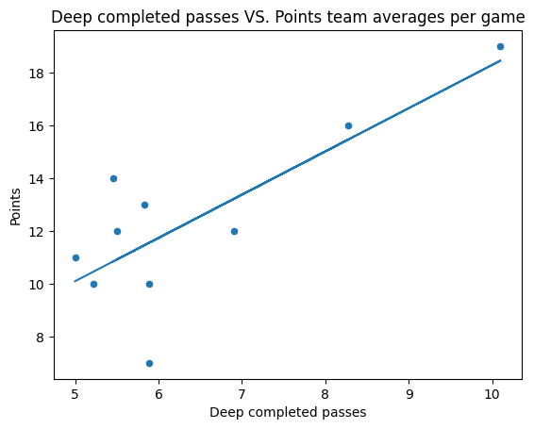

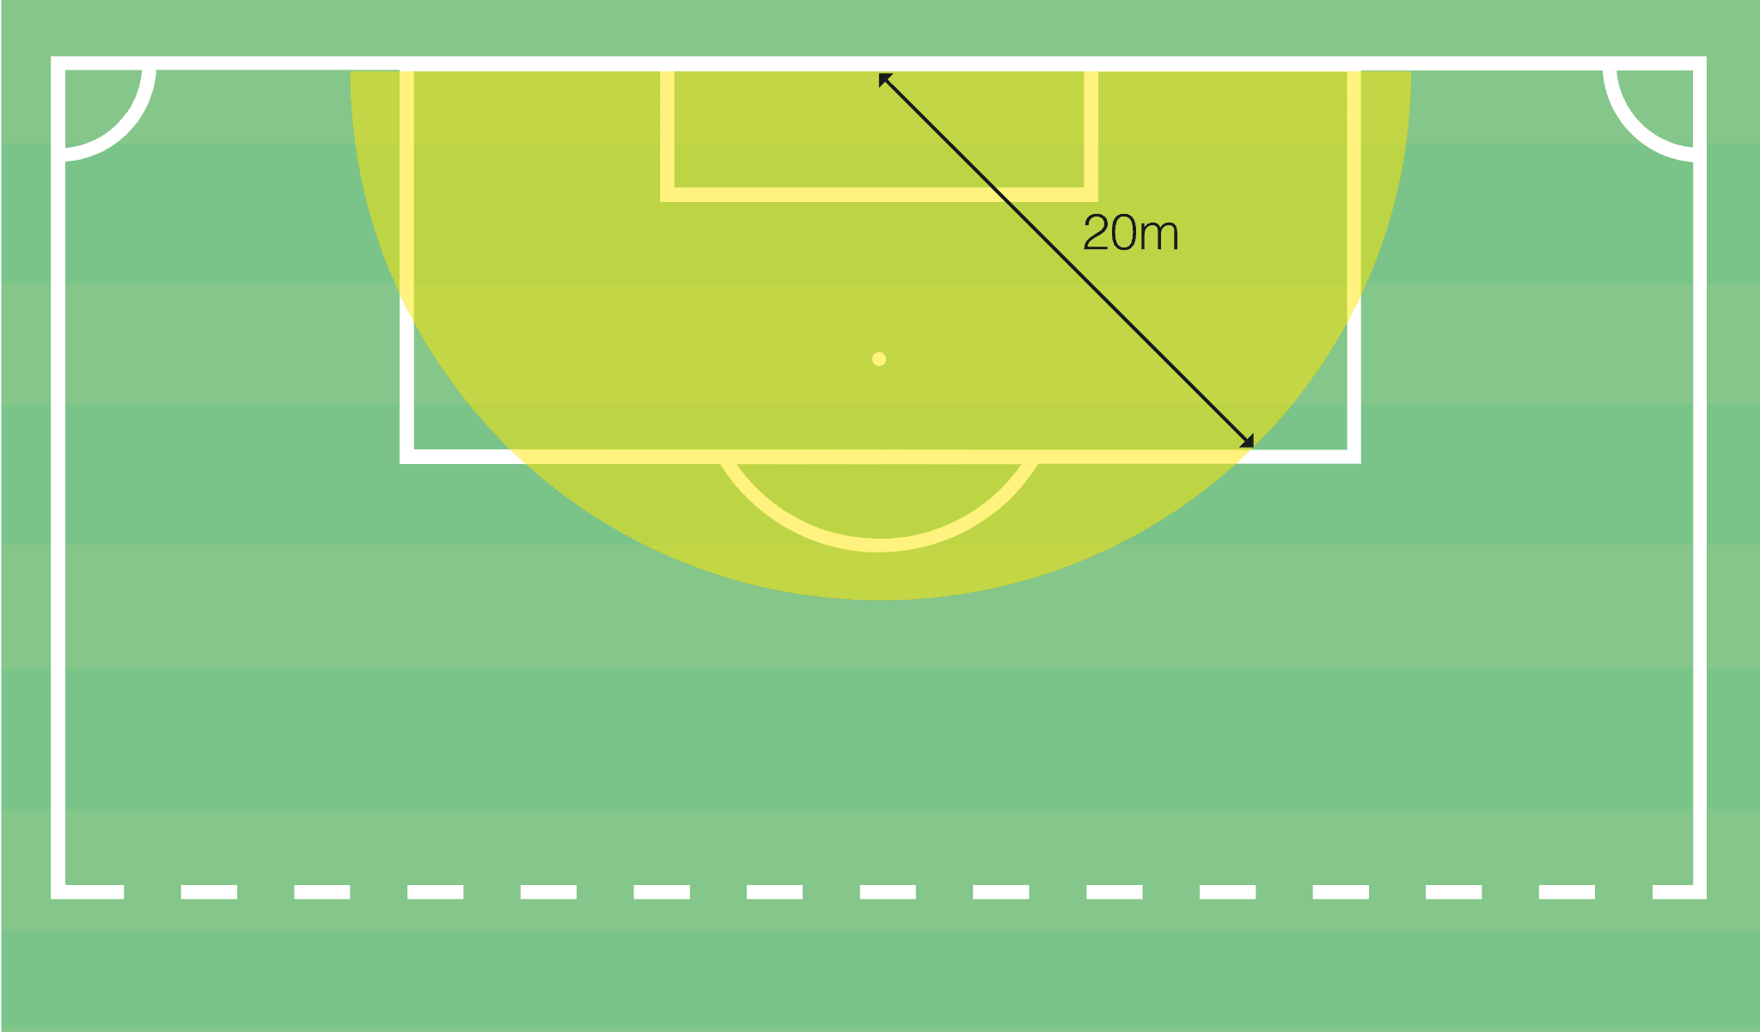

Deep Completed Passes Correlation to Points - .78

Deep Completed Passes Slope to predict Points - 1.64

Meaning - For every additional deep completed pass per game on average the points a team finishes with increases by 1.64.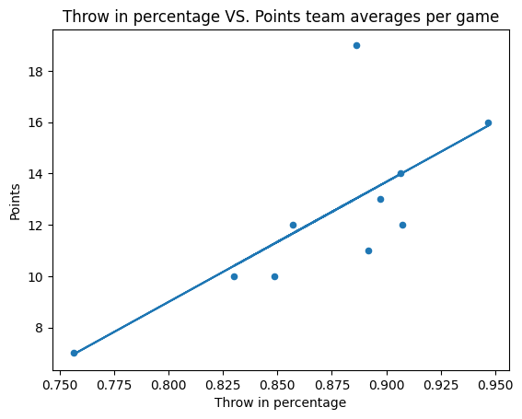

Throw in Percentage Correlation to Points - .73

Throw in Percentage slope to predict Points - 46.74

Meaning - For every 1% increase in throw in percentage the points a team is expected to finish with increases by .46

For a 10% increase in throw in percentage the expected points a team gets increase by 4.6.

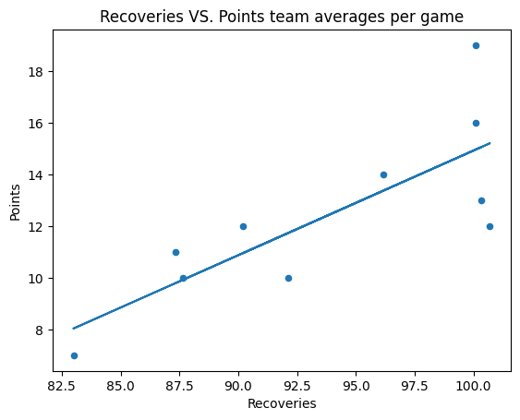

Recoveries Correlation to Points - .79

Recoveries slope to predict points - .41

Meaning - For every additional recovery per game the points a team is expected to finish with increase by .41, increase 5 recoveries and an increase of 2 points.

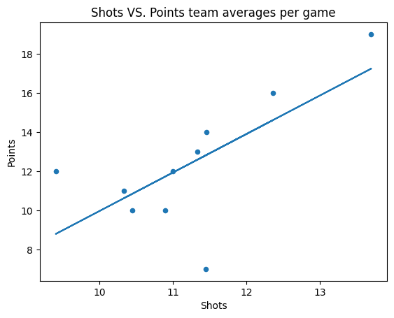

Shots Correlation to Points - .68

Shots slope to predict points - 1.96

Meaning - For every additional shot per game the points a team is expected to increase 1.96 points.

## 

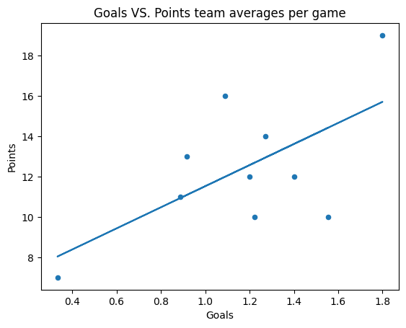

Goals Correlation to Points - .62

Takeaway - Goals appear to have a somewhat strong relationship to points but take away the two extremes and that relationship goes away. Average goals per game is not a high tier feature in predicting points a team finishes with.

## 

Conclusion:

* Deep penetrating passes lead to success on a consistent basis
* More recoveries in a game enable a team to have success
* Focus and concentration on little things like throw-ins help teams perform in the long run
* Teams that can consistently get a lot of shots in game tend to do better overall

# UCSD Analysis

## Overall

Goal differential is a good measure of the offense and defense of a team and UCSD was second to last in average goal differential in the Big West at -.33.

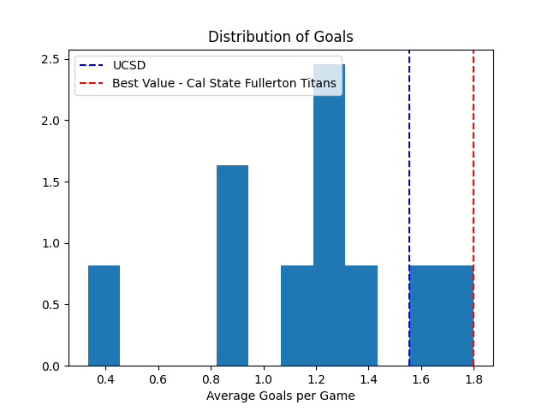

UCSD has an average goals scored in the league of 1.55. Which is a significant increase from the average number of goals scored in all games they played. The team that won the league (Fullerton) had the most goals per game average in the league

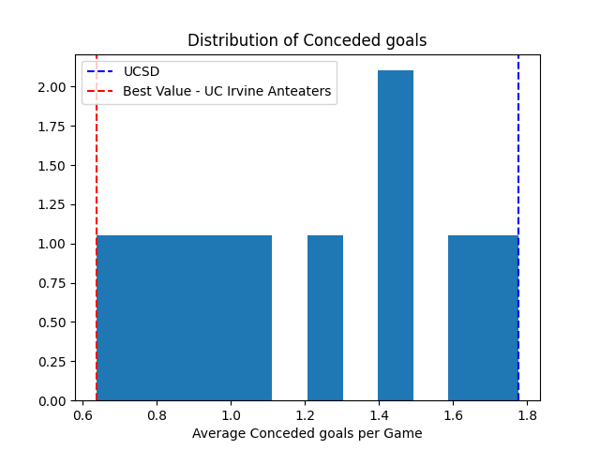

UCSD has the worst goals conceded per game average in the league of 1.77. Which is a decrease from including all games UCSD played. UC Irvine had the best goals conceded per game average at .64 and finished 2nd in the league.

**How to maximize goal differential:**

**Maximizing Chances Created - Shot on target accuracy and maximizing Goals-xG**

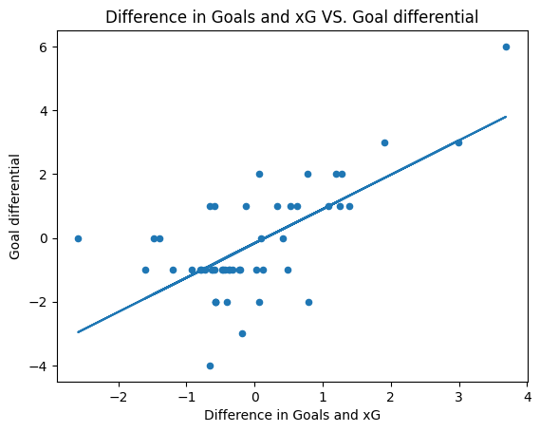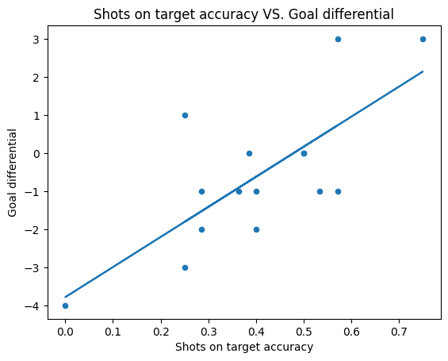

**Building up to create chances - Maximize Forward Passes, Crossing, and Long Passes Accuracy**

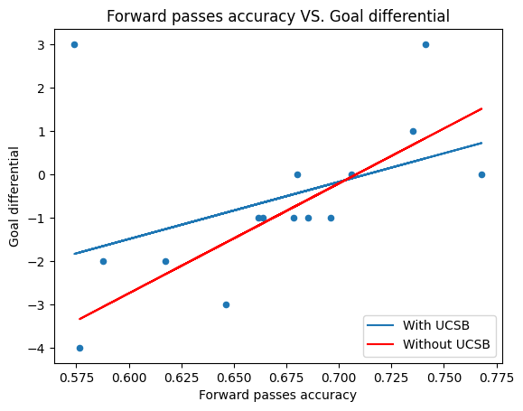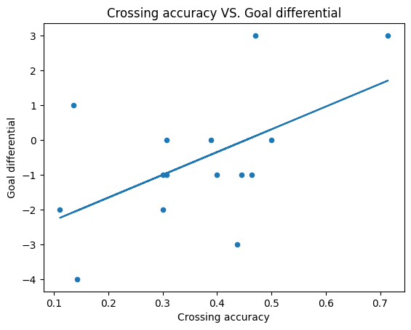

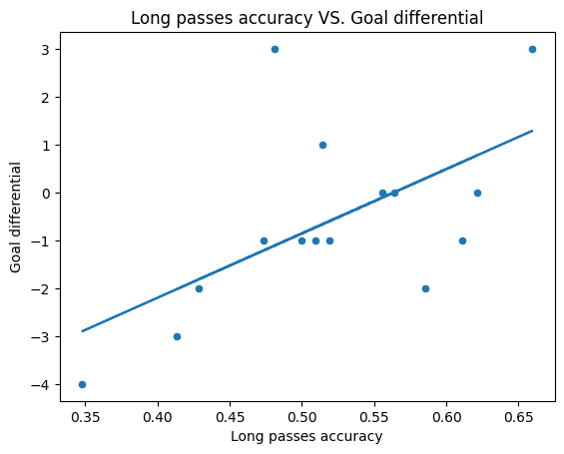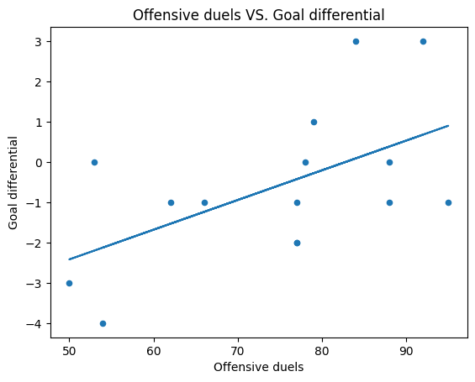

**Physicality - Yellow Cards**

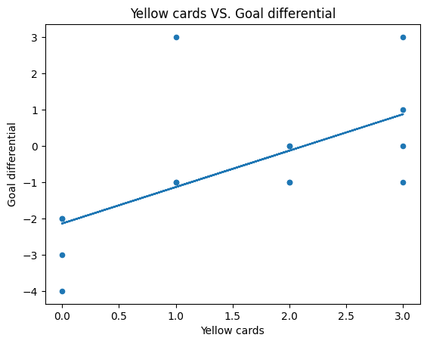

**How to maximize Goals:**

**More Offensive Duels (Taking players on), Shots on target accuracy, Crossing Accuracy, Less average pass per possession**

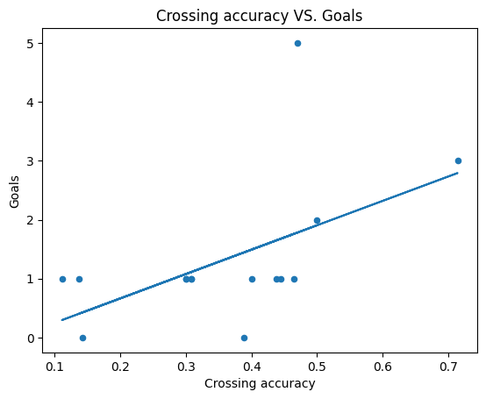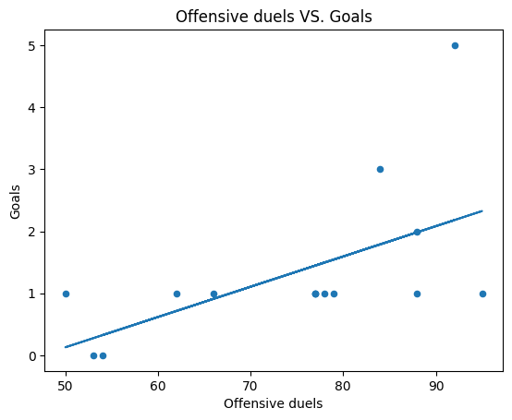

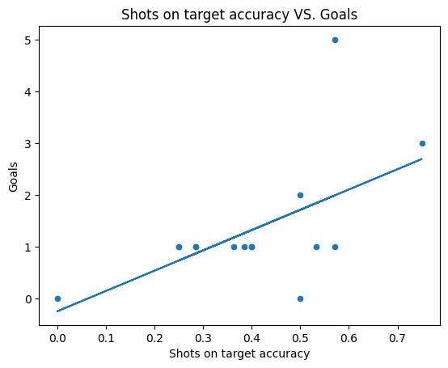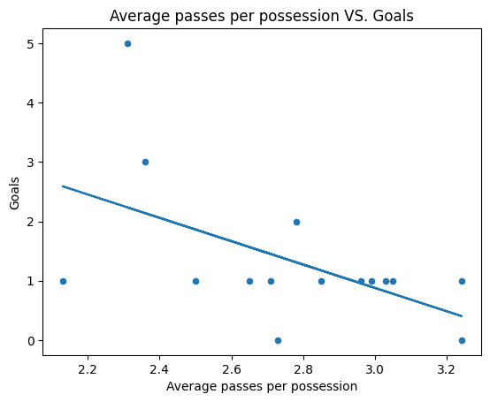

**Maximize xG i.e. Creating more high quality goal scoring chances:**

**Num Deep Completed Crosses, Lower Average Shot Distance, Forward Passes Accuracy, Minimizing Losses in Midfield**

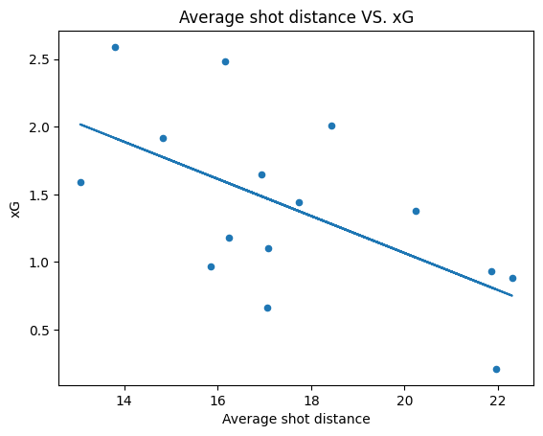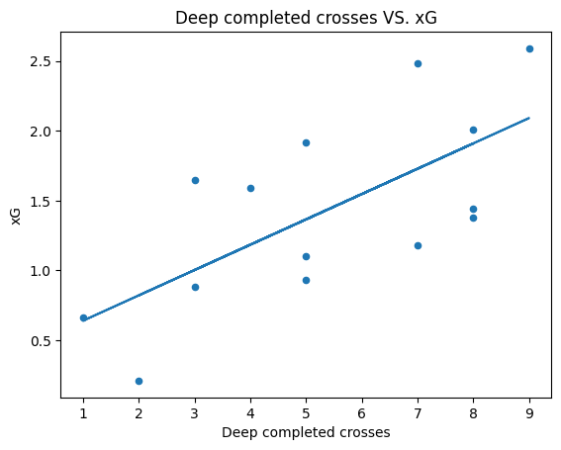

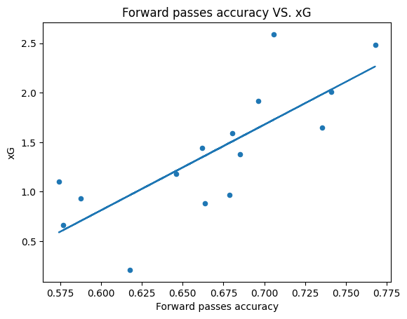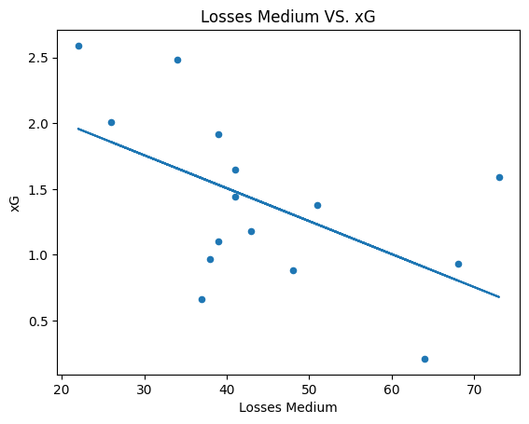

**Minimize Conceded Goals:**

**Physicality (Yellow Cards), Winning Aerial Duels, Passing Forward Accurately**

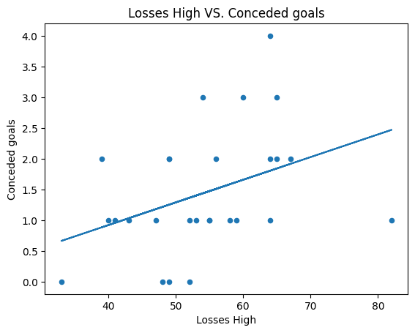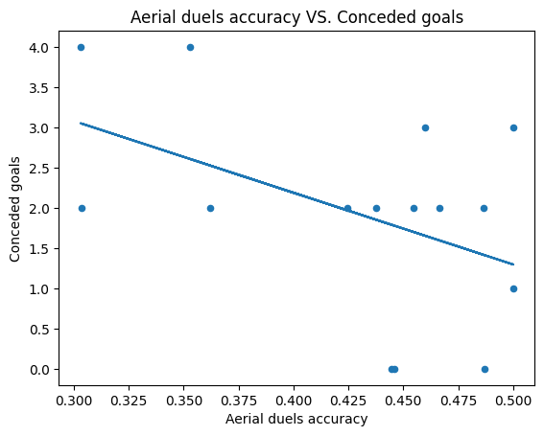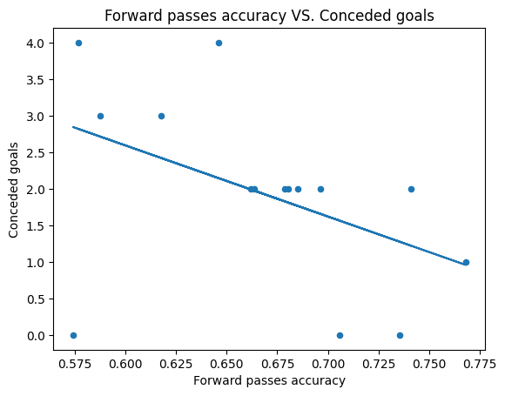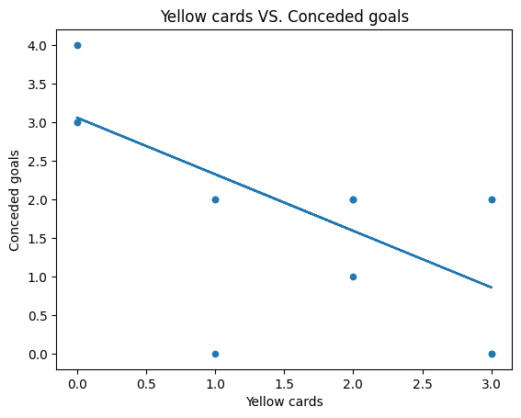

Smaller details:

Going long more or passing backwards more leads to more losses and less chances and goals

Being able to place long balls more accurately does lead to more chances

Tend to have more chances and less conceded goals at a slower match tempo

Allowing more passes per defensive action slightly tends to lead towards more conceded goals

### Key Factors:

* **Crossing Accuracy - Key to Maximizing Goal Differential, Goals, xG**
* **Shot on Target Accuracy - Key to Maximizing Goal Differential andGoals**
* **Forward Pass Accuracy, Key to Maximizing Goal Differential, xG, and Minimizing Conceded Goals,**
* **Offensive Duels - Key to Maximizing Goal Differential and Goals**
* **Physicality - Key to Maximizing Goal Differential and Minimizing Conceded Goals**

## Offense

### Goal Scoring Chances in League Play

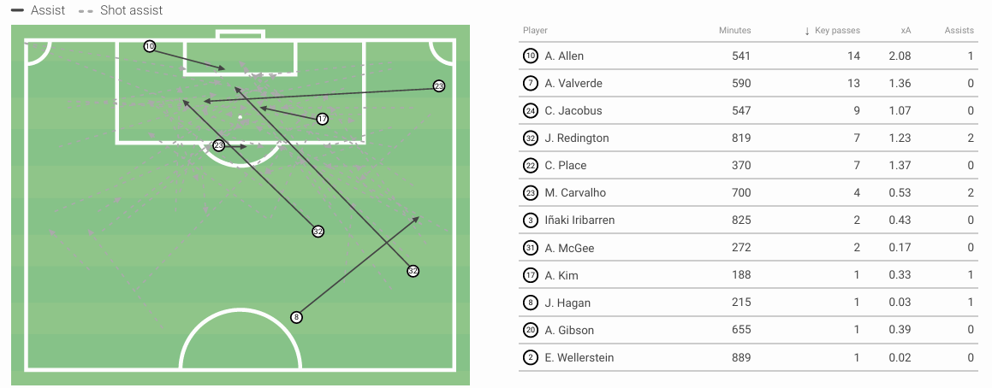

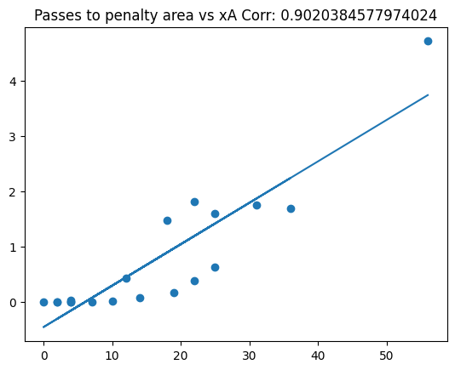

Passes into the penalty box create the highest quality chances. For every 10 passes into the penalty area a player is expected to get .8 of an assist. Valverde leads the team significantly in the amount of passes into the penalty area.

#### Shots

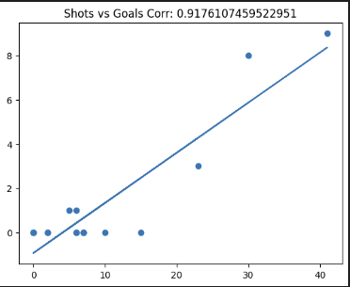

The players on UCSD who took more shots scored more goals. On average for every 5 shots a player takes they are expected to score 1 goal.

We tend to have a lot more success with our shots when they are inside the box. Additionally, when the shots are on the left side of the goal.

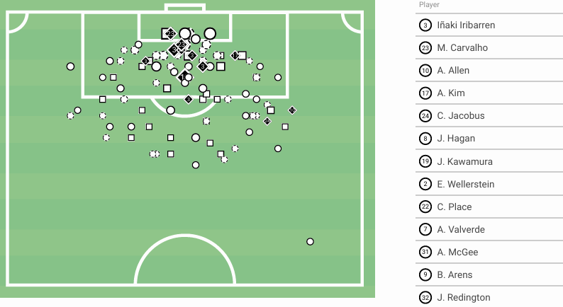

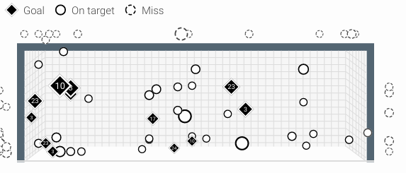

#### Taking Players on

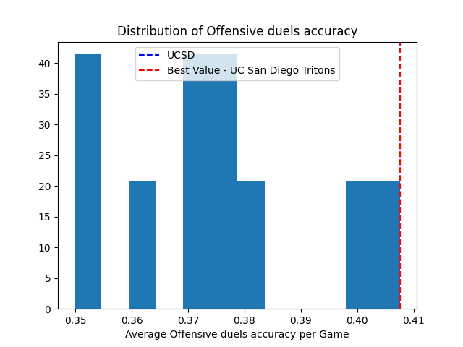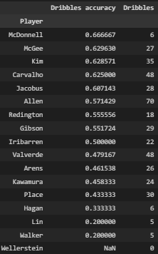

Overall the ability for UCSD to take on the opposition and beat them is the best in the league and have a lot of players who can consistently beat the other team.

McGee and Carvalho lead the offense in being able to get past players over 60% of the time

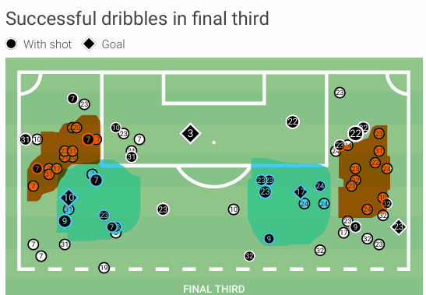

Successful Areas

Unsuccessful Areas

Dribbles seem to have a very high success rate to the sides of zone 14 as players have the option to take it wide or cut back inside while dribbles on the sides of the box tend to have the least success as there are less places to dribble to.

#### Crosses

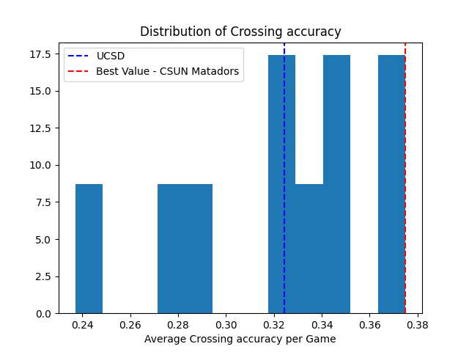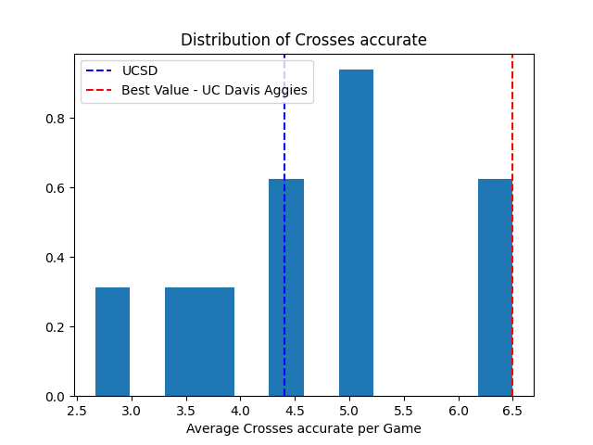

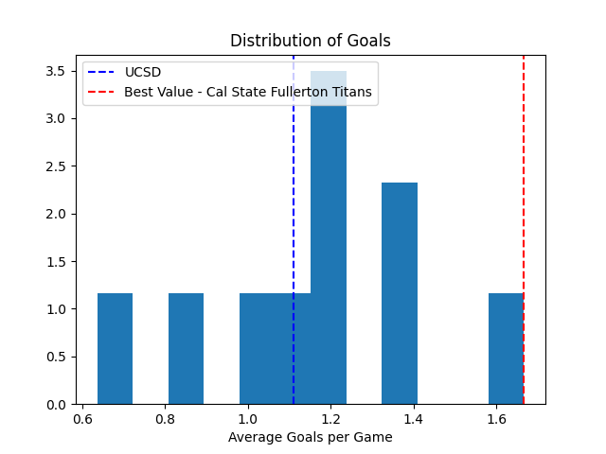

In the league UCSD had one of the highest consistent crosses per game and crossing accuracy overall and was in the middle of the pack in goals scored. Crosses only accounted for 2 of the 12 goals in league games.

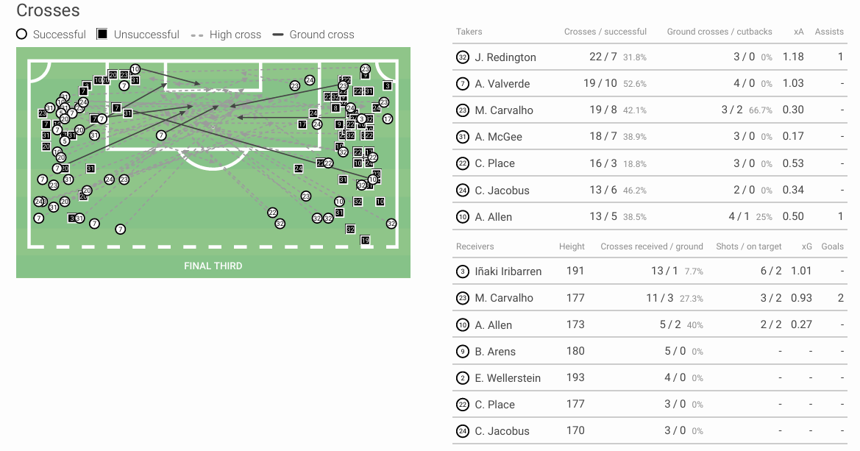

As a player crosses the ball more often the expected assists they get increases. For every 12.5 crosses they should get at least 1 assist

**Players we want to cross:** Redington, Valverde, Jacobus, McGee

**Players to avoid crossing:** Place and Arens - Very low crossing accuracy

### Passing

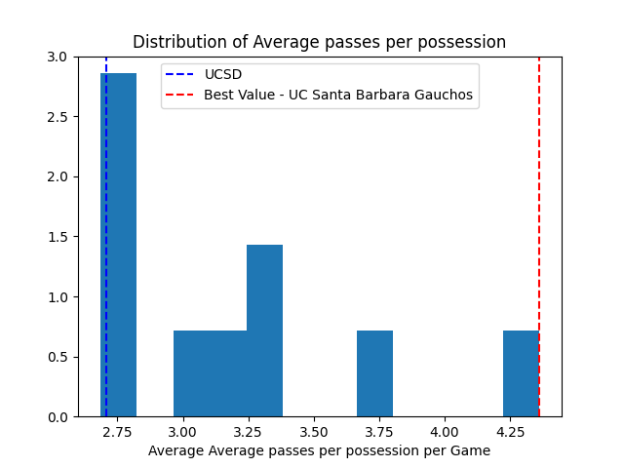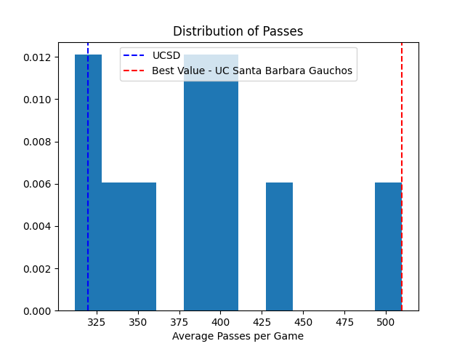

UCSD has one of the lowest number of passes per game and average passes per possession in the league which lead almost every team to dominate UCSD in possession, but it is not significantly correlated to losing results.

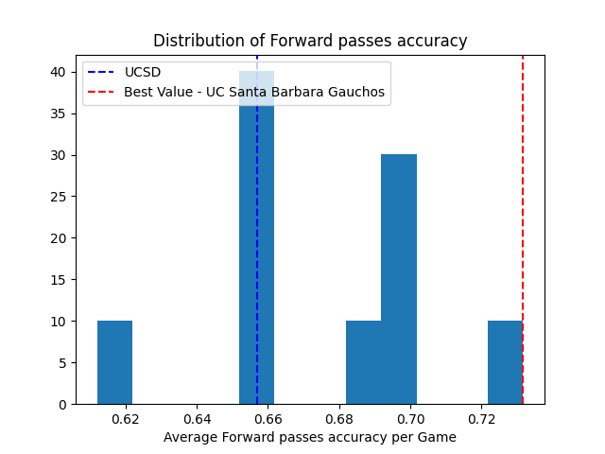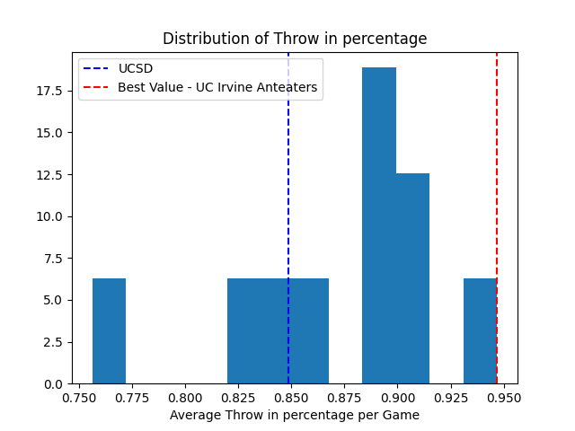

Forward passing accuracy is one of the biggest factors in success that UCSD has had yet they are near the bottom of the league in that statistic. Additionally UCSD is also near the bottom in throw in percentage and throw in percentage is a big component of long term focus and success in the league. Increasing standing in these areas would greatly improve success.

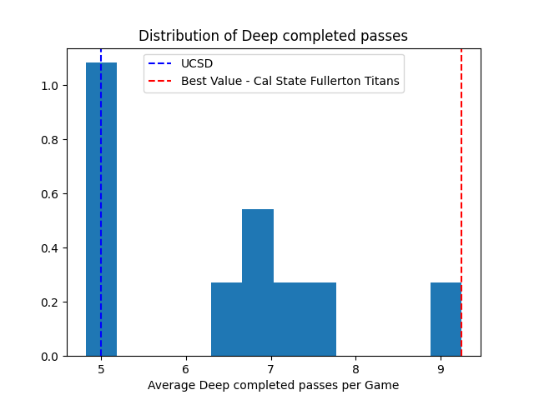

Deep completed passes are one of the biggest factors that leads to goal scoring opportunities and UCSD is near the bottom of the table at 5 deep completed passes on average per game while league champs Fullerton are at 9 deep completed passes.

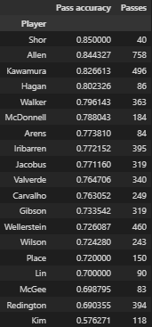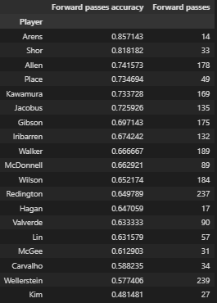

**Returning Players to Highlight:** Kawamura, Arens, Jacobus

**Players of Concern:**

**Wellerstein** - CB that starts the attack and is at the bottom in being able to complete forward passes.

**Redington** - Outside back crucial in build up and has one of the lowest passing percentages.

**Lin** - Outside back big in build up and also low in passing percentage.

**McGee -** Attacking midfielder absolutely crucial in attack and has a low pass percentage and forward pass percentage.

## Defense

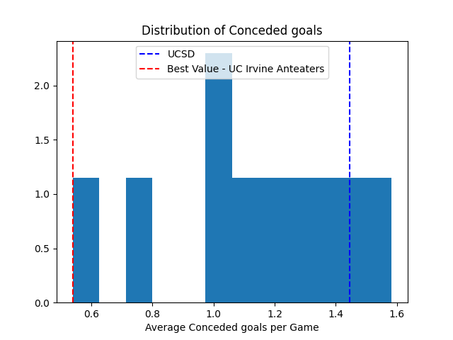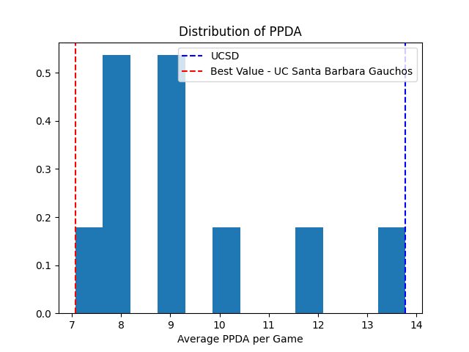

This is the largest area of concern for UCSD as they are second to last in the league in conceded goals per game at 1.44 conceded goals per game. Additionally UCSD allows the most passes per defensive action in the league by a great amount at 13.46 passes per defensive action. While the top 3 teams in the league are under 9.

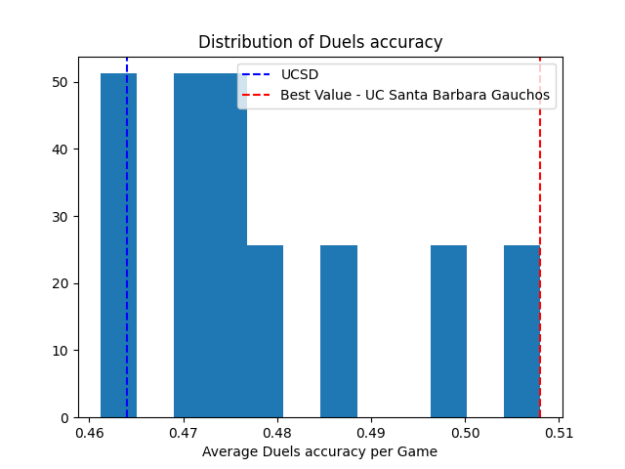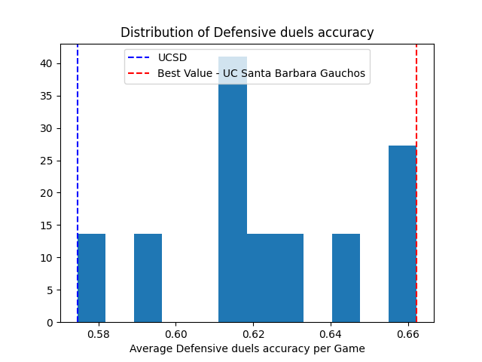

Another key breakdown in defense is the defensive duels percentage in which UCSD sits last again on the table at 58.9%. Defensive duels are crucial in limiting the amount of attacks the other team has.

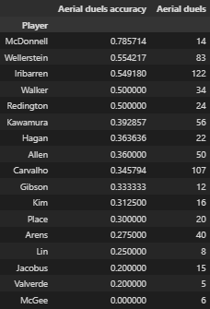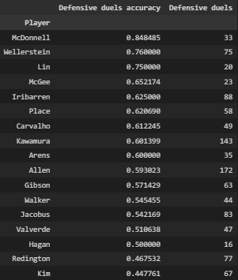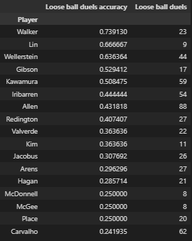

**Returning Players to Highlights:**

Wellerstein - Strong in all facets of duels

Lin - Strong in ground defensive duels and loose ball duels weak in aerial battles

Jonah - Solid all around.

**Players of Concern:**

Redington - Has a very low defensive duels accuracy but is decent in the air.

Carvalho - Has a very low loose ball win rate under 25% if improved could lead to more chances at striker

### Goalkeeping

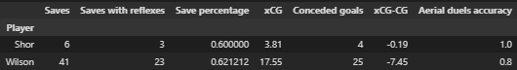All Games

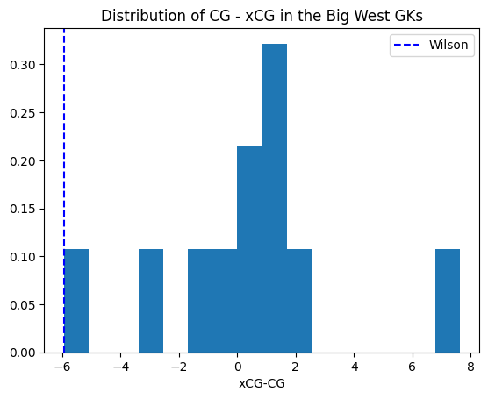

Histogram of each goalkeeper in the big west and their expected amount of conceded goals minus their actual amount of conceded goals in Big West games.

The amount of goals that Wilson conceded is significantly higher than the amount of goals he was expected to concede. He has the lowest difference in expected conceded goals and actual coned goals in the entire league and by a significant amount.

# Glossary

##### Deep Completed Pass

* - A non-cross Pass that is targeted to the zone within 20 meters of the opponent’s goal.

##### Deep Completed Cross

* A Cross that is targeted to the zone within 20 meters of the opponent goal.

##### Recovery

* Any Action that ends a Possession of the opposition team (the last action of this possession is a Loss) and starts a Possession for the current team.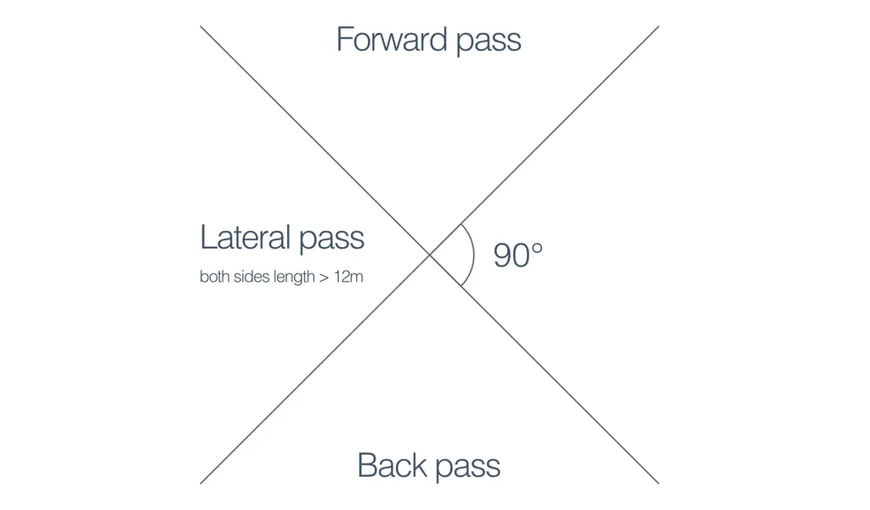

##### Passes

##### Offensive Duel

* A ground Duel for the player in possession of the ball. When the attacking player uses their ability and skill in an attempt to pass an opponent, this is also a Dribble.
* However, when the player in possession is required to protect the ball with his body, although this is an offensive duel, it is not a Dribble.

##### Defensive Duel

* When a player attempts to dispossess an opposition player to stop an attack progressing.

##### Aerial Duel

* When two or more players from opposing teams jump to compete for the ball.

##### Loose Ball Duel

* A duel for a loose ball, when no team has clear ball possession.

##### xG

* Expected goals

##### xCG

* Expected conceded goals

##### Losses

* A loss is recorded at the point where the player of the team actually loses the possession of the ball. For non-passes, this would be equal to the point of his last action, but, for example, with an unsuccessful long pass, the loss will be recorded at the ending point of the pass, not at its starting point.
* Events where the ball goes off the field off a player are, by definition, losses.
* Suffered foul, while ending a possession, is not considered a loss.
* Zone: High / Mid / Low / Own Half
  + Based on the coordinates of the loss, the loss is awarded a zone. Low / Mid / High correspond to the thirds of the field (low is own third, high is the final third), while own half losses are all losses that happen in the own half.